CHAPTER 11

Sustainable Agriculture Management in the Juwana Sub-Watershed

Eva Banowati, Aprillia Findayani & Adhitya Prasetya Adji

Abstract

Juwana Watershed which has a relatively large catchment area, spread between the North Kendeng Mountains, the Pati Ayam Mountains, and Mount Muria. The existence of a watershed has an important role for the surrounding community. At present in the Juwana watershed there is a huge of critical land due to inappropriate land management with the rules of conservation. The shape of the watershed is rounded, this caused frequent flooding. This fan-patterned river caused rainwater down the mountain towards the Juwana River and causing overflow during rainy seasons and making the river dry up quickly in the dry season. These conditions need a special action for agriculture to adapt to the local conditions. Sustainable agricultural systems in principle is a system which are back to nature, do not damage, do not change, harmonize, and balance with the environment. To realize that, some agricultural activities carried out in the Juwana watershed the local community implemented several patterns and agricultural activity including 1) Crop Rotation; 2) Cover Crop; 3) Land Management; 4) Integrated Agriculture; 5) Integrated Pest Management, and 6) Organic Cultivation. Sustainable agriculture in the Juwana watershed aims to create a farming system that reduces environmental hazard as part of a larger movement towards sustainable development, which recognizes that natural resources are limited, the limits of economic growth, and encourages equity in resource allocation.

Keywords: Sustainable Agriculture, Juwana Watershed, Integrated Agriculture

A. Introduction

Indonesia is an agrarian country, approximately 28.79 percent of the population do farming activities as their main livelihood (Sakernas, 2018). This is supported by the natural conditions and resources. The location of Indonesia which is in the ring of volcanoes provides its advantages in the form of fertile soil as a result of volcanic activity produced by approximately 160 active volcanoes. Agriculture is a type of production activity based on the growth process of flora and fauna, humans take a role in the process of cultivating plants and animals as well as regulating in meeting their needs (Banowati & Sriyanto, 2013).
In its implementation, this activity requires humans/communities to take on various agricultural businesses to produce effective and efficient products. Agricultural business is a biological industry that utilizes materials and biological processes to obtain appropriate profits for the perpetrators which are packaged in various subsistence ranging from pre-production, production, harvest, post-harvest subsystems, distribution and marketing. An agricultural business system can be said to be environmentally sound if in its management it applies advanced technology that is environmentally friendly or does not cause negative externalities to the environment both the biophysical environment and the economic social environment at the micro and macro levels (Adnyana, 2016).
Many factors affect agricultural production such as soil conditions, land area, seed quality, fertilizer, and other physical and natural factors. The relationship of each of these factors will determine the effectiveness of an input on the acquisition of production and the size of the negative impact caused by the environment. So it is necessary to understand a basis of an integrated agriculture pattern that prioritizes the use of natural resources as much as possible before deciding on the use fossil energy as expressed by El-Titi and Landes (1990).
The development growth in various sectors that are triggered by population growth cause a decrease in the hydrological conditions of a watershed. The phenomena of decreased watershed hydrological function can be found in several regions of Indonesia, such as Java, Sumatra, and Kalimantan (Effendi, 2008). Asdak (2010) defines a watershed as a land area that is topographically limited by ridges that collect and store rainwater to then channel it into the sea through the main river. The land area is called a catchment area which is a regional ecosystem whose main elements consist of natural resources (land, water, and vegetation) and human resources as natural resource users.
The watershed, which is an ecosystem, consists of various biogeophysical components that interact with each other. In the watershed system as an input occurs in the form of rain and human intervention, processes that occur in the watershed and output in the form of production, runoff, and sediment. The output of this interaction can be positive or negative. Some negative impacts will certainly be a problem for both the environment and humans such as erosion, environmental pollution, flooding, and others.
Land use that exceeds the carrying capacity of land and land use that is not in accordance with land suitability will certainly cause environmental degradation (Figure 11.1). This happens in various places including the Juwana watershed. Upstream of the Juwana watershed located on the slopes of Mount Muria there has been a conversion of land from forest to non-forest. This land conversion results in critical land in the upper reaches of the watershed mainly caused by erosion. Figure 11.1 in addition to giving a real picture that as much as 56% of land damage is caused by erosion as the main factor and 27% of agricultural activity as a hereditary factor.

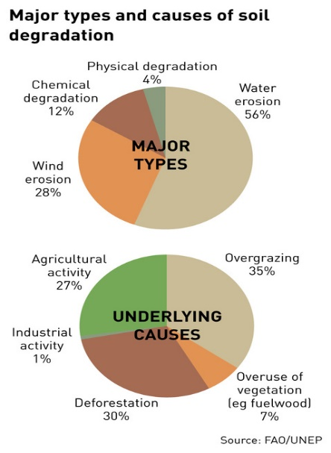

Figure 11.1 Causes of soil degradation
Source: FAO (2011)

Juwana watershed with the main river Kali Juwana has length of 58.34km located in a geographical position between 110 ° 49 '10' - 111 ° 12 '57' 'East Longitude and 6 ° 36' 48 '' - 6 ° 59 '29 '' South Latitude with an area of 130391.33 ha. Rainfall in the Juwana watershed ranges between 2000 - 3000 mm/year with temperatures of 23-32°C. Wet months are 5-12 months, while dry months are 5-9 months. Juwana watershed consists of 5 districts 32 sub-districts and 352 villages.
Varied agricultural activities carried out by the community around the Juwana sub-watershed have resulted in a decline in soil quality which has indirectly resulted in a decline in agricultural output from year to year. Therefore, there needs to be an effort to be able to minimize or reduce the impact of environmental damage as a result of agricultural activities. This chapter discusses agriculture in the Juwana sub-watershed which covers the types of agriculture and how farming communities adapt to climate change that occurs while sticking to the concept of sustainable agriculture.

B. Agriculture Activity in Juwana Watershed

A watershed can be used for various development interests, especially the fulfillment of human needs, for example for agricultural areas, plantations, fisheries, settlements, hydropower development, utilization of timber forest products, and others. However, the use of this watershed area must pay attention to several criteria which is can cause some negative environmental impacts if not handled properly. This will cause a decrease in the level of production, both production in each sector and at the watershed level. Therefore, efforts to manage the watershed properly by synergizing the development activities in the watershed are needed not only for the sake of maintaining the ability of production or economic development, but also to avoid natural disasters that can be detrimental such as floods, landslides, drought, and others.
Juwana watershed has a total area of 146,668.68 Ha which is divided into 6 sub-watersheds called Gungwedi sub-watershed, Landaraguna sub-watersheds, Piji sub-watersheds, Sani sub-watersheds, Sukosungging sub-watersheds, and Wates sub-watersheds (Figure 11.2). The Juwana watershed area covers 28 sub-districts in 4 different districts. The widest subdistrict area is Pati Regency, which covers 17 districts including Batangan, Gabus, Gebog, Gembong, Jaken, Jakenan, Juwana, Kayen, Margorejo, Winong, Pati, Puncak Wangi, Sukolilo, Tambakromo, Tlogowungu, Trangkil, and Districts Wedarijaksa. Kudus Regency covers 7 districts called Dawe, Jekulo, Mejobo, Bae, Kota Kudus, Jati, and Undaan Districts. Grobogan Regency covers 3 districts which are Grobogan, Brati, and Wirosari Districts. While Blora Regency covers 1 sub-district, Todanan District (Cahyo, SN.2013).

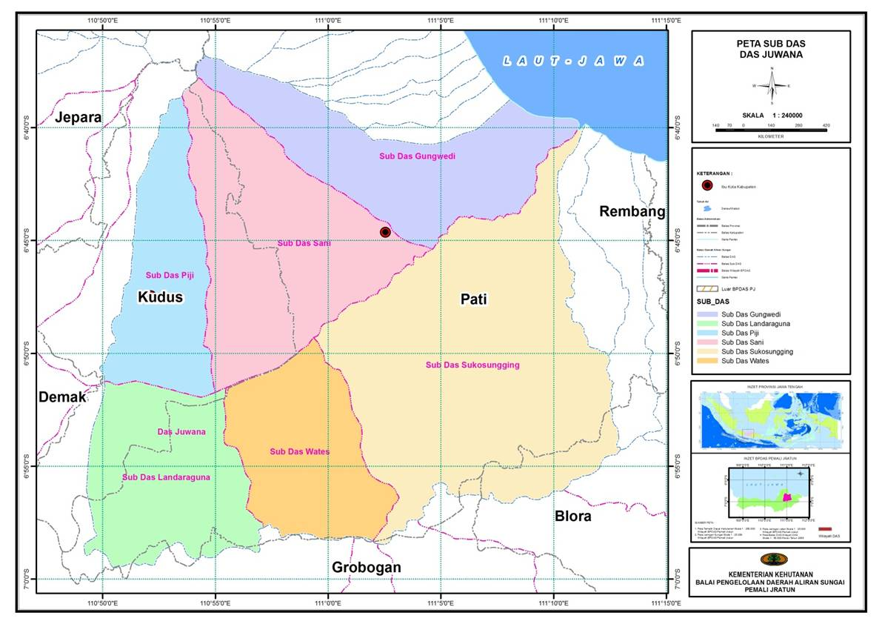
Figure 11.2 Juwana watershed
Source: http://sipdas.menlhk.go.id

Communities in the Juwana river basin are agrarian communities. Based on the 2013 Agriculture Census, agricultural households in 5 districts crossed by the Juwana watershed reached one million families. In addition to agriculture, this sectors include plantations, forestry, and fisheries.
In the upstream Juwana watershed, there is a forest bio core whose use is based on mixed vegetation conservation functions. On the other hand, there are coffee plantations that are dominated by Robusta varieties at an altitude of 700 masl. The plantation has been operating since the Dutch colonial era. At present the plantation is managed by PT. Perkebunan Nasional (PTPN IX). In the middle watershed is based on water management functions with cotton tree plantation (Ceiba Pentandra). Followed by limited production forests, teak-vegetated production forests (Tectona Grandis) are applied to agroforestry overlapping patterns, and agriculture under wisely managed stands (Banowati & Prajanti, 2017). In the downstream, the people's livelihoods include several agricultural sectors in a broad sense. Residents of rice farming, soybeans, including fisheries. The existence of rice fields is supported by irrigation water from Gunungrowo reservoir and Gembong reservoir.
Agriculture is a sector that is very dependent on environmental conditions. Soil conditions, rainfall, air temperature, and sunlight are just some of the environmental factors that affect agriculture. Not to mention the pest cycle which is also influenced by weather changes. Feeling unable to handle the challenges of nature alone, farmers usually live in groups. Types of plants, when to plant, and many matters relating to agricultural activities are usually decided in group meetings. If you do something different from the group's decision, the farmer feels that you will face increasing uncertainty. Therefore, the types of plants in an agricultural area are usually uniform. Especially if the soil conditions are the same. Likewise, that can be found in this region. Rice has become one of the most popular commodities of farmers in Central Java, as well as farmers in this region. In 2017, the total area of paddy fields in five regencies in this region was around one-third of paddy fields in Central Java. Most of the rice fields in this area are irrigated rice fields, except for rice fields in the Rembang area which are still mostly rain-fed. Rice fields are around 40% of the total area of each regency, except Pati and Blora (BPS, 2018).
In addition, because it is in a karst area that has a surface that tends to dry, plants that can survive on dry land, there are several plants such as corn, soybeans, beans, and sweet potatoes are also quite attractive to farmers. The northern region is even known as one of the soybean farming areas. Grobogan Regency is the main soybean producer in Central Java. The areas adjacent to it, such as Pati, Rembang, Kudus, and Blora, are also known as potential areas for soybean development. Even in 2017, soybean production in these 5 districts contributed to 60% of Central Java soybeans.

C. Sustainable Agriculture Concept

The fact that the amount of land that can be utilized for agricultural land is running low is quite difficult to understand, but the fact that some of the main options for meeting the increasing demand for global food production results in complex problems in land use policies. On the one hand we might be able to increase the amount of land devoted to agriculture or better known as agricultural extensification. On the other hand, we can also intensify by increasing yields that we can get from land that has been devoted to planting. But whatever efforts we will take, both have flaws. Intensification causes massive soil depletion, but devoting more land to intensive agricultural use is accelerating the loss of aggregate of arable land available to feed a growing planet with an increased appetite for food production that makes a great demand for soil resources.
Dimiyati (1992) expressed the influence of population and population growth on the management of an agricultural area in an effort to make it a sustainable agricultural pattern. They explained that with the increasing number of population in an area will urge intensive land use to meet their needs. So that efforts to increase production will shorten the rest period on the soil while the absorption of nutrients from the soil is getting bigger.
From Table 11.1, it can be seen that from 12 samples, 11 of them contained grain containing Pb metal which was allegedly a combination of agricultural activities and physiological factors that form soil which is formed by karts. Although it is still below the Pb content threshold set by WHO which is 2, but this needs to be a concern given this content is harmful to health and can cause various diseases.
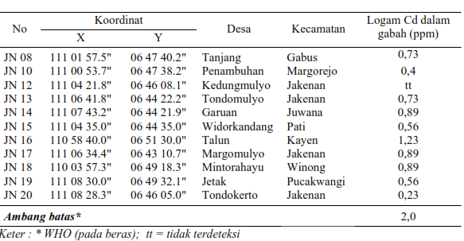
Table 11.1 Pb metal content in Juwana watershed 2009
Source: Mulyadi (2013)
Various conventional agricultural business practices that have been running so far have not been felt to pay attention to environmental sustainability. In addition to producing a variety of products offered to consumers, agricultural business can also cause various negative externalities including: air pollution from methane gas; soil, water and air pollution from pesticides and herbicides; water and air pollution from residual fertilizer that is not absorbed by plants; and soil erosion by wind and water. The level of negative externalities that results greatly depends on the farming patterns adopted by agricultural business actors (Dimiyati et. al., 1998).
In line with Dimiyati (1992), Smukler et al (2012) argue that without increased productivity on agricultural land, extensification of agricultural production will likely be needed to meet increasing food demand. But this will add to the greater effect that results in global warming caused by the increase in carbon dioxide (CO₂) released from the conversion of land into agricultural use. The alternative is to increase productivity on existing land. But that requires the application of nitrogen fertilizer which is likely to increase the release of nitrous oxide (N₂O), a greenhouse gas 310 times stronger than CO₂.
The above statement is reminiscent of a number of concepts presented by several experts in the early 80s and 90s. O'Connell (1990) states a new concept by suppressing the supply of chemicals as small as possible for agricultural businesses in an effort to produce sufficient food and continue to maintain land productivity and prevent environmental pollution for unlimited use. Richard (1990) expresses this new concept of agriculture as a concept of sustainable agriculture or known as the term Sustainable Agriculture in accordance with the term used by Jackson (1980) and the regenerative agriculture concept of Rodale (1983) both of which are a pattern of sustainable agriculture that maintains sustainable support the environment to production all the time.
Various considerations that need to be considered in developing a sustainable agricultural business system include: (1) Consideration of adequate profitability for the perpetrators, (2) Consideration of the quality of long-term environmental services so that the business becomes a source of income and a decent living, (3) Quality considerations short-term and long-term macro environment, and (4) Consideration of sustainability for biological resources in the form of flora and fauna that can be cultivated (Suryana & Adnyana, 1997).
Furthermore, Adnyana and Simatupang (1996) convey a number of strategies that can be implemented as an effort to realize the sustainability of an agricultural system, including:

- The agricultural system to be achieved as far as possible is realized through the use of internal resources to substitute the use of external resources.
- Reducing or increasing the use of artificial fertilizers sourced from non-renewable resources such as chemical fertilizers.
- Reducing the intensity of the use of pesticides and herbicides and the mass application of the Integrated Pest Management (IPM).
- Expanding the application of crop rotation and horizontal diversification to improve soil fertility, control pests and diseases increase productivity and reduce risk.
- Maintaining crop residues and external inputs and planting cover crops to maintain soil moisture and fertility.
- Reducing the number of livestock units per unit area of land or livestock stocking rates.

The concept of sustainable development in Indonesia began to be formulated in the late 1980s as a response to an earlier development strategy that was more focused on the main objectives of high economic growth, and which was proven to have led to a degeneration of production capacity and environmental quality resulting from resource exploitation excessive. Initially this concept was formulated in the Bruntland Report as a result of the World Commission on Environment and Development of the United Nations Commission on Environment and Development in 1987. It was simply stated that sustainable development was development which embodies the needs of life today without reducing the ability of future generations to realize their needs. The implementation of economic development that is socially just carried out without sacrificing the environment, so the development carried out at this time must also consider the needs of the next generation of life.
Considering the importance of sustainable development in all aspects of human life, in 1992, all world leaders met at the world conference in Rio de Janeiro, Brazil, which discussed the concept of sustainable development for all aspects of social, economic, cultural and environmental life that is well known for name of Agenda 21. One of the agenda 21 which is directly related to the agricultural sector is the Sustainable Program Agriculture and Rural Development (SARD). The moral message to create better environmental conditions for all generations is universally accepted by leaders the world, so sustainable agriculture has become the basic principle of agricultural development throughout the world, including in Indonesia (Rivai, R. S., & Anugrah, I. S. 2016).
The various efforts above certainly require full support from both the government and farmers. Efforts to sensitize farmers to preserve the land they use for farming are crucial to be realized immediately. Until now in several areas in the Juwana sub-watershed, efforts have been made to improve soil quality and reduce pollutants that can reduce environmental quality and affect the quality and quantity of agricultural products.

D. Community and Sustainable Agriculture in Juwana Watershed

Most of the watersheds in Indonesia are in critical condition. One indicator that can be used as a reference is the occurrence of floods, droughts and landslides whose intensity is increasing every year and widespread critical land (Wijayanti, 2011). In Surat Keputusan Menteri Kehutanan (Minister of Forestry Decree) No. SK.328 / Menhut-II/2009 states that as many as 108 watersheds are in critical condition that requires priority handling. In Indonesia, critical land is still growing and has reached 77.8 million hectares (Departemen Kehutanan, 2007). Based on the decree, Juwana watershed is Priority Watershed I which means that this watershed is included in the critical category (Keputusan Menteri Kehutanan Republik Indonesia. 2009).
The Juwana river basin which has a fairly large water catchment area spread between the North Kendeng Mountains, the Pati Ayam Hills and the Muria Mountains, has an important role for the surrounding community. However, the current conditions are estimated to have occurred considerable land changes both in the forestry sector, agriculture and other sectors. At present in the Juwana watershed there is a large area of degraded land due to improper land management or not in accordance with conservation principles. These changes need to be monitored to determine the right policy.
The decline in land quality is mainly due to physical and chemical damage to the land as well as the decline in biodiversity, raising environmental activists and the community's concerns about the unsustainability of agricultural production due to the adoption of the green revolution. Agricultural cultivation technology innovations, especially lowland rice, as an effort to increase land productivity through sustainable farming systems have been found and applied in several areas, both by government and non-government institutions.
Increased production and agricultural production can be achieved through the application of technological innovation by developing farming patterns based on sustainable agriculture systems. According to Salikin (2003) a sustainable agricultural system in principle is back to nature, namely an agricultural system that does not damage, does not change, harmonious, and is in harmony with the environment or agriculture that is obedient and subject to the rules - natural creed. Sustainable agriculture systems also contain moral invitations to do well in the environment of natural resources by considering environmental awareness, economic value and social character.
Sustainable farming systems such as those mentioned by Horrigan, Lawrence and Walker (2002) can be implemented using several technological approaches or system models, including organic farming systems, integrated farming systems, low output input farming systems and integrated pest control systems, as well as other technologies such as biological fertilizer technology and integrated crop management. Some agricultural activities carried out by the people who live in Juwana sub-watershed which is an embodiment of sustainable agriculture include:

- Crop rotation. This concept applies two or more types of plants which are planted alternately on agricultural land. This method aims to break the chain of breeding of pests and plant diseases. One of the advantages of this system is that farmers can reduce the use of fertilizers because in some cases one type of plant will be able to produce natural fertilizer for the type of plant to be planted next.
In sustainable agriculture systems, secondary crops is one component in the application of the burden for irrigation, especially when irrigation is not able to provide enough water for lowland rice. In some areas in Pati Regency, farmers rotate crops by planting rice interspersed with crops to break the life cycle of rat pests. This crop rotation is proven to increase productivity of local agricultural products. On the other hand, crops can also be used to maintain the watershed environmental conditions as a barrier to the rate of degradation.

- Cover crops. Cover crops are planted to improve soil quality, prevent soil erosion, and minimize weed growth. Some cover crops can also generate income. One of the forest management which involves the community by using the planting pattern is how to manage the forest by applying a mixed planting pattern between the types of forestry plants and agricultural crops. Perum Perhutani has long been involved in intercropping, namely working with communities around the forest through forest land contracts as an embodiment of agroforestry implementation (Banowati, 2001).
For example, the cultivation of Arabica Coffee, which was developed by many people in the upstream Juwana watershed. In its implementation, the community also planted Lamtoro (Leucaena leucocephala) which in addition to protecting the soil from possible erosion also had economic value that could plague farmers' incomes.

- Land management. Good soil management involves managing its chemical, biological and physical properties. Industrial agriculture tends to emphasize the chemical properties of soils, thus harming the other two. One hectare of healthy soil can contain 4 tons of organisms, which form a soil ecosystem. Organic material and compost are beneficial foods for bacteria, fungi, nematodes, and protozoa. If managed properly, these soil organisms perform vital functions that help plant growth. Healthy soils produce stronger plants and are therefore less susceptible to pests.
Forest and land rehabilitation in the Juwana watershed has been carried out vegetative since 2001 until now which includes community forestry programs, village nurseries, mangrove rehabilitation, Alley Cropping and green belts. The Local Government also provides seedlings to community forest farmers to increase community participation in the Gerakan Nasional Rehabilitasi Hutan dan Lahan (National campaign for land and forest rehabilitation).

- Integrated agriculture. This system is also known as LEISA (Low-External Input and Sustainable Agriculture). Kathleen (2011) states that crop-livestock integration farming can improve soil quality, increase yields, produce diverse food and improve land use efficiency. The benefits of crop-livestock and fish-fish integration can be synthesized through: (1) agronomic aspects, namely increasing the capacity of the land to produce, (2) economic aspects, namely diversification of products, higher yields and quality, and lower costs, (3) ecological aspects namely reducing pest attacks and pesticide use, and erosion control, and (4) social aspects, namely more equitable distribution of income. Integrated agriculture, according to Tipraqsa et al. (2007) can also create new jobs in rural areas so that urbanization is reduced. Some areas in Pati Regency implement integrated farming of production plants and livestock such as rice and fish and are cultivated as minapadi.

- Integrated pest management (IPM). Integrated pest management systems prefer biological methods and use chemical pesticides only as a last resort. To control damaging insects, IPM emphasizes crop rotation, intercropping, and other methods to disrupt the pest cycle, as well as varieties of plants that have high resistance to pests. IPM also uses insect protection, as well as biopesticides such as Bt.

- Organic cultivation. The concept of organic farming provides promising prospects in line with the increasing public awareness of healthy living. The other side of organic cultivation is reducing the amount of use of chemicals that enter the soil and are absorbed by plants which can cause adverse effects on health. Plant cultivation with organic treatment using materials that are natural enemies of pests such as laos, turmeric, lemongrass which all the ingredients were crushed and boiled, then just take the water (Figure 11.3). Application using a spray tool with a dose of 220 ml or the size of a glass of bottled mineral water mixed with 14 liters of water (Adji, 2019).
This cultivation system can be found in several villages in Kayen District, Pati. Another thing that is found on the farms cultivated in organic treatment is the provision of aquatic plants on the edge of the trench to reduce chemicals carried through water from adjacent paddy fields. Farmers believe that aquatic plants are able to absorb residual chemical residues from nearby land that is carried by water. In addition, water plants that die will also help composting the soil so that there are other advantages obtained by farmers with organic treatment.

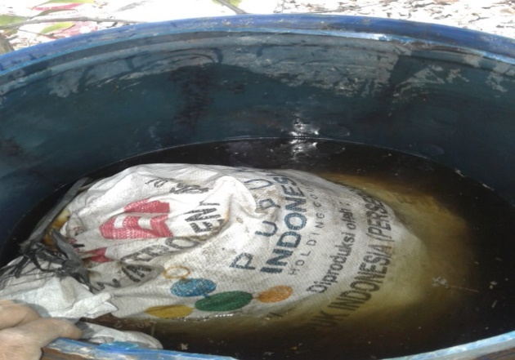
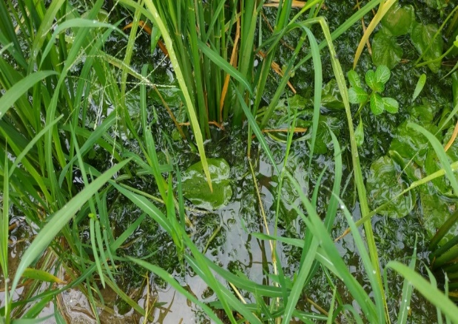
Figure 11.3 Use of animal manure as organic fertilizer and utilization
water plants as a reduction of chemical fertilizer residues
Source: Adji (2019)

In the effort to implement the concept of sustainable agriculture, it is necessary to have active participation from the government through related agencies and agencies, environmental activists, stakeholders and the farming community as implementing agricultural activities and businesses. A participatory approach by actively involving the community to recognize the potential and constraints they face in developing an agricultural business system is an alternative that must be considered. A populist and decentralized agricultural business system built in a participatory manner is guaranteed to be sustainable. However, the approach should consider: (1) Agricultural business is developed is a choice of the community, (2) Active community participation as a potential actor in the process of developing a farming business system, and (3) Agricultural business system must be able to substantially improve the welfare of the community.

E. Conclusion

One of the goals of the sustainable agriculture movement is to create an agricultural system that reduces or eliminates environmental hazards associated with industrial agriculture. Sustainable agriculture is part of a larger movement towards sustainable development, which recognizes that natural resources are limited, recognizes the limits of economic growth, and encourages equity in resource allocation.
The importance of the watershed's position as a whole planning unit is a logical consequence to maintain the sustainable use of forest, land and water resources. Inaccurate planning can lead to bad watershed degradation as stated above. In an effort to create an integrated watershed management approach, planning is needed in an integrated, comprehensive, sustainable and environmentally friendly manner by considering the watershed as a management unit. Thus, if there is a disaster, whether it is flooding or drought, mitigation can be carried out thoroughly covering the watershed from the upstream to downstream areas.
The development of appropriate technology in the perspective of the agricultural business system should consider the superiority shown by farmers' technology. These advantages must be accommodated in the creation of improved technology and introduction to farmers' technology. Existing farmer institutions are containers that can be used to accelerate the process of dissemination of location-specific appropriate technologies.

F. References

Adji, A. P. (2019). Analisis komparatif pertanian padi dengan perlakuan organik dan anorganik serta dampaknya terhadap kualitas tanah di Desa Kayen dan Desa Jimbaran Kecamatan Kayen Kabupaten Pati. Skripsi. Semarang: Universitas Negeri Semarang.
Adnyana, M. O., & Simatupang, P. (1996). Pengkajian dan pengembangan sistem usaha pertanian berbasis komoditas unggulan. In Prosiding Lokakarya BPTP/ LPTP Se Indonesia. BPTP Naibonat, Kupang.
Adnyana, M. O. (2016). Pengembangan sistem usaha pertanian berkelanjutan. Forum Penelitian Agro Ekonomi, 19(2), 38-49.
Asdak, C. (2010). Hidrologi dan pengelolaan daerah aliran air sungai (5th Ed.). Yogyakarta: Gadjah Mada University Press.
Banowati, E. (2009). Kesiapan masyarakat dalam mewujudkan pembangunan sumber daya hutan berkelanjutan di kawasan hutan Muria Wilayah Pati-Jawa Tengah. Laporan Penelitian Hibah Program Doktor. Yogyakarta: Universitas Gadjah Mada
Banowati, E. (2001). Agrosilvikultur dan peningkatan pendapatan pesanggem. Thesis. Yogyakarta: Fakultas Geografi, Universitas Gadjah Mada.
Banowati, E., & Prajanti, S. D. W. (2017). Developing the understand cropping system (PLDT) for sustainable livelihood. Management of Environmental Quality: An International Journal, 28(5), 769-782.
Banowati, E., & Sriyanto. (2013). Geografi pertanian. Yogyakarta: Penerbit Ombak.
Badan Pusat Statistik. (2013). Sensus pertanian 2013. Retrived from http//bps.go.id
Badan Pusat Statistik. (2018). Jawa Tengah dalam angka. Retrieved from http//bps.go.id
Cahyo, S. N. 2013. Tingkat Kerentanan Banjir Dengan Penginderaan Jauh Dan Sistem Informasi Geografis Daerah Aliran Sungai Juwana Di Kabupaten Pati Jawa Tengah. Doctoral Dissertation. Surakarta : Universitas Muhammadiyah Surakarta).
Departemen Kehutanan. (2007). Lahan kritis per BPDAS tahun 2007. Situs Resmi Departemen Kehutanan. Retrieved from http://www.dephut.go.id.
Dimiyati et al. (1998). Pembangunan Sistem Usaha Pertanian Berkelanjutan. Prosiding Analisis Ketersediaan Sumberdaya Pangan dan Pembangunan Pertanian Berkelanjutan. Badan Litbang Pertanian 1997-1998.
Dimiyati, N. (1992). Strategies for sustainable mountain agriculture in the Hindu Kush-Himalayan Region. SCS. Ankeny. Iowa. USA.
Effendi, E. (2008). Kajian Model Pengelolaan Daerah Aliran Sungai (DAS) Terpadu. Direktorat Kehutanan dan Konservasi Sumberdaya Air, Bappenas.
El-Titi & Landes. (1990). Integrated farming system of Lautenbach: A practical contribution toward sustainable agriculture in Europe. Ankeny. Iowa, USA: SCS.
FAO. (2011). FAO soil and land degradation. Report 3, Retrieved from https://fao.org
Horrigan, L., Lawrence, R. S., & Walker, P. (2002). How sustainable agriculture can address the environmental and human health harms of industrial agriculture. Environmental Health Perspectives, 110(5), 445-456.
Jackson, W. (1980). New roots for agriculture. U of Nebraska Press.
Kathleen, H. (2011). Integrated crop/livestock agriculture in the United States: A review. J. Sustainable Agric., 35, 376-393.
Keputusan Menteri Kehutanan Republik Indonesia No. SK.328/Menhut- II/2009 tentang Penetapan Daerah Aliran Sungai (DAS) Prioritas Dalam Rangka Pencana Pembangunan Jangka Menengah (RPJM) Tahun 2010-2014.
Mulyadi. (2013). Logam berat Pb pada tanah sawah dan gabah di sub-das Juwana Jawa Tengah. Agrologia, 2(2), 95-101.
O’Connell, P. (1990). Policy development for low-input sustainable agriculture program. Iowa, USA: SCS AnKeny.
Richard, R. H. (1990). A history of sustainable agriculture. Iowa, USA: SCS Ankeny.
Rivai, R. S., & Anugrah, I. S. (2016). Konsep dan implementasi pembangunan pertanian berkelanjutan di Indonesia. In Forum Penelitian Agro Ekonomi (Vol. 29, No. 1, pp. 13-25).
Rodale, R. (1983). Breaking new ground: The search for sustainable agriculture. The Futurist, 1(1), 15-20.
Sakernas. (2018). Survey Angkatan Kerja Nasional 2017. Retrieved from https://mikrodata.bps.go.id/ mikrodata/index.php/catalog/SAKERNAS
Salikin, K. A. (2003). Sistem pertanian berkelanjutan. Yogyakarta: Kanisius.
Sistem Informasi Pengelolaan DAS. 2019. http://sipdas.menlhk.go.id
Smukler, S. M., Jackson, L. E., O'Geen, A. T., & Ferris, H. (2012). Environmental tradeoff assessment for best management practices on an organic farm in a Mediterranean-type climate. Journal of Soil and Water Conservation 67, 16-31.
Suryana, A., & Adnyana, M. O. (1997). Pengembangan sistem usaha pertanian dalam era globalisasi ekonomi. Prosiding agribisnis dinamika sumberdaya dan pengembangan sistem usaha pertanian PSE, Bogor.
Tipraqsa, P., Craswell, E. T., Noble, A. D., & Schmidt-Vogt, D. (2007). Resource integration for multiple benefits: Multifunctionality of integrated farming systems in Northeast Thailand. Agric. Sys., 94, 694-703.
Wijayanti, R. (2011). Studi identifikasi pengelolaan lahan berdasar Tingkat Bahaya Erosi (TBE) (Studi kasus di sub DAS Sani, DAS Juwana, Jawa Tengah). Jurnal Ilmu Lingkungan, 9(2), 57-61

